Contrast-Enhanced Emotion Recognition Using Lightweight CNNs

Shahid Kamal
College of Engineering
Northeastern University
Boston, MA, kamal.sh@northeastern.edu

Abstract
Facial Expression Recognition (FER) is a key task in affective computing, enabling machines to interpret human emotions from visual cues. This project focuses on classifying emotions from facial images using the FER2013 dataset. We implement and compare two approaches: a lightweight custom Convolutional Neural Network (CNN) and a transfer learning-based model using a pre-trained ResNet architecture. The dataset is preprocessed using normalization and data augmentation to enhance generalization. Both models are trained to classify seven core emotions— anger, disgust, fear, happiness, sadness, surprise, and neutral. Performance is evaluated using accuracy scores and confusion matrices. While the custom CNN serves as an efficient baseline, the ResNet-based model demonstrates superior accuracy due to its deeper representational power. The project highlights the importance of model architecture and transfer learning in improving FER performance under varying facial conditions.
.

1 Introduction
Facial emotion recognition (FER) is a key problem in the field of computer vision and affective computing, with growing relevance in applications such as human-computer interaction, virtual assistants, security systems, and healthcare monitoring. The task involves automatically identifying human emotional expressions — such as happiness, sadness, anger, or surprise — from facial images. While humans are naturally adept at recognizing emotions, automating this process poses significant challenges due to intra-class variation, subtle expressions, and diverse lighting or pose conditions. Among the most widely used benchmarks for FER is the FER2013 dataset, which consists of 48x48 grayscale facial images labeled with seven basic emotion classes. Despite its popularity, the dataset suffers from noisy labels and low-resolution images, making it difficult to achieve high accuracy with simple models. Convolutional neural networks (CNNs) have shown promise in this domain, offering automatic feature extraction and robust classification. However,
CNN performance heavily depends on preprocessing quality and the depth of the architecture used.
In this project, I investigate the effectiveness of two deep learning pipelines for facial emotion recognition: a lightweight custom CNN trained from scratch, and a deeper pretrained ResNet18 model fine-tuned on FER2013. To improve robustness under varying lighting conditions, we introduce Contrast Limited Adaptive Histogram Equalization (CLAHE) as a preprocessing step to enhance local contrast in facial images. I compare both models in terms of accuracy, training time, and generalization, providing insights into the trade-offs between custom architectures and transfer learning in resource-constrained environments.

2 Related Work
Facial emotion recognition (FER) has become a pivotal task in affective computing, with the FER2013 dataset serving as a popular benchmark for evaluating model performance. Numerous studies have tackled this challenge using convolutional neural networks (CNNs) and their variants. Khaireddin and Chen (2021) achieved a remarkable 73.28% accuracy on FER2013 using a fine-tuned VGGNet architecture, emphasizing the strength of transfer learning approaches. Georgescu et al. (2018) proposed a hybrid model that combined deep features with handcrafted descriptors using a local learning framework, pushing performance to 75.42%. Similarly, the Stanford CS230 team (2020) explored ensemble-based CNN architectures, achieving over 75% accuracy by integrating multiple models and refining feature extraction. While these studies utilized heavyweight models, Gursesli et al. (2024) focused on lightweight CNN architectures based on MobileNetV2, reaching 63% accuracy, which is promising for deployment on edge devices. Furthermore, Oguine et al. (2022) proposed a hybrid real-time FER system that combined deep learning with traditional Haar Cascade classifiers, attaining around 70% accuracy. These works collectively underscore that highperforming FER systems benefit from both robust feature extraction (via CNNs or transfer learning) and thoughtful preprocessing strategies. However, most existing pipelines still rely on raw grayscale images without enhancing local contrast. This motivates the novelty in our work, where we integrate Contrast Limited Adaptive Histogram Equalization (CLAHE) into the preprocessing pipeline and explore its impact on CNN-based FER performance. Additionally, we incorporate Grad-CAM visualizations to improve interpretability and transparency in emotion classification, offering a more explainable and human-aligned model.

3 Methodology
This project implements a comparative study between two convolutional neural network (CNN) architectures for facial emotion recognition using the FER2013 dataset. The methodology is designed to evaluate the impact of contrast enhancement through CLAHE (Contrast Limited Adaptive Histogram Equalization), and to compare the effectiveness of a custom lightweight CNN against a pretrained ResNet18 model.
The FER2013 dataset, which contains grayscale facial images of 48x48 pixels labeled with seven emotion categories (angry, disgust, fear, happy, sad, surprise, and neutral), was used as the benchmark. All input images were first preprocessed using CLAHE to improve contrast and enhance local features, such as the mouth, eyes, and eyebrows, which are critical for emotion classification. Additional transformations included resizing to a consistent resolution and applying data augmentation techniques such as random horizontal flipping and rotation to improve model generalization. The first model is a lightweight custom CNN consisting of three convolutional layers with batch normalization, ReLU activation, max pooling, and dropout. This model was trained from scratch using cross-entropy loss and the Adam optimizer. The second model uses a ResNet18 architecture pretrained on ImageNet. The original input layer was adapted to accept grayscale input, and the final classification layer was replaced with a new fully connected layer for 7-class emotion prediction. Initially, the pretrained layers were frozen to train only the classifier, and later, fine-tuning was performed on the deeper layers.
Both models were trained for up to 25 epochs with early stopping based on validation accuracy. Performance was evaluated using test accuracy, loss curves, and confusion matrices. To further interpret model behavior, class-wise accuracy and classification reports were generated. The methodology allows for a side-by-side analysis of training time, model complexity, and performance metrics, providing insight into the trade-offs between custom lightweight models and transfer learning approaches for real-world emotion recognition tasks.

4 Results
This section evaluates and compares the performance of three facial emotion recognition models trained on the FER2013 dataset: a baseline CNN, a custom CNN enhanced with CLAHE and augmentation, and a pretrained ResNet18 model. Each approach was analyzed in terms of training behavior, final accuracy, per-class performance, and qualitative predictions. The baseline CNN, trained from scratch with basic grayscale input and no advanced preprocessing, achieved a final test accuracy of 58.58% (Figure 1). It showed a stable decrease in loss across epochs and consistent improvement in test accuracy. Despite its simplicity, it performed remarkably well on the “happy” class while struggling with emotions like “fear” and “disgust.” The confusion matrix (Figure 2) highlighted frequent misclassifications across subtle emotions, and top 3 predictions revealed limited confidence, often misidentifying clearly expressive faces.
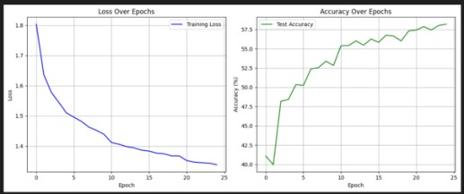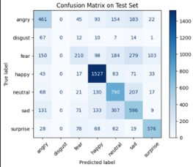
Figure 1: Training Loss and Test accuracy Figure 2: Confusion Matrix on test set of baseline
The custom CNN introduced Contrast Limited Adaptive Histogram Equalization (CLAHE) during preprocessing and applied data augmentation such as rotation and flipping. Surprisingly, while the model’s (Figure 3) test accuracy (58.57%) remained nearly identical to the baseline, its training was more stable, and class-wise accuracy distribution improved slightly. The confusion matrix (Figure 4) showed slightly better separation for neutral and surprise categories, and top 3 predictions were better calibrated. This model also generalized better with fewer fluctuations, suggesting improved robustness, even if top 1 performance was not dramatically higher.
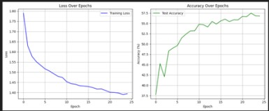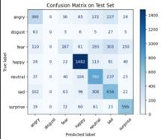
Figure 3: Training Loss and Test accuracy of Custom CNN Figure 4: Confusion Matrix on test set of Custom CNNs
In contrast, the pretrained ResNet18 model, despite its depth and prior training on ImageNet, underperformed with a final test accuracy of only 41.90% (Figure 5). Although its training loss steadily decreased, the accuracy plateaued far below expectations. The confusion matrix (Figure 6) showed widespread misclassification, with most classes having significantly lower true positive counts compared to the CNN-based models. Its best performance remained on the “happy” class, though even this lagged the simpler models. That said, its top 3 predictions demonstrated more nuanced distribution, reflecting stronger uncertainty estimation even when top 1 classification failed.
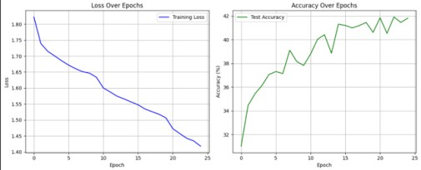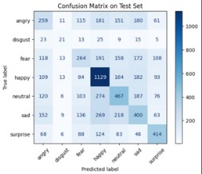
Figure 5: Training Loss and Test accuracy of ResNet Pretrained Figure 6: Confusion Matrix
Overall, the results demonstrate that lightweight CNNs, when paired with dataset-specific preprocessing like CLAHE, can outperform much deeper pretrained networks on small, grayscale datasets like FER2013. The limited size and quality of FER2013 make it challenging for high-capacity models to generalize without overfitting or requiring extensive fine-tuning. Additionally, the misclassification trends across all models (especially for fear, sad, and neutral) point to intrinsic limitations of the dataset, including overlapping emotional expressions and noisy labels. These findings suggest that model simplicity, when combined with effective preprocessing, can outperform brute-force deep models in constrained data settings — an insight particularly relevant for deployment on edge devices or low-resource environments.

5 Conclusion
This project explored the task of facial emotion recognition on the FER2013 dataset using three different convolutional neural network approaches: a baseline CNN trained from scratch, a custom CNN enhanced with CLAHE preprocessing and data augmentation, and a deeper ResNet18 model pretrained on ImageNet. The baseline CNN served as a strong starting point, achieving 58.58% test accuracy, with solid performance on expressive classes such as “happy” and “surprise.” The custom CNN, which integrated contrast enhancement via CLAHE and simple augmentations, resulted in similar accuracy (58.57%) but improved learning stability and class balance, demonstrating the value of targeted preprocessing even with a shallow architecture. In contrast, the ResNet18 pretrained model, though more powerful, underperformed at 41.90% accuracy — likely due to the mismatch between the color-rich ImageNet training data and the grayscale, low-resolution FER2013 dataset. Across all models, common trends included strong bias toward highly expressive emotions, such as “happy,” and persistent misclassification in subtle or overlapping classes, particularly “fear” and “disgust.” This highlights not only the challenge of the dataset itself, but also the limitations of standard classification pipelines in interpreting nuanced human emotions. In conclusion, this study shows that model simplicity combined with contrast enhancing preprocessing can outperform more complex architectures in data-constrained environments. Lightweight CNNs, when properly designed and trained, offer competitive performance while maintaining efficiency and interpretability. For future work, directions may include experimenting with attention-based models, facial landmark fusion, or applying this pipeline to cleaner and more diverse datasets like FER+ or AffectNet.

6 Future Work

While the current study provides valuable insights into model design for facial emotion recognition, several promising directions remain for future exploration. One of the most immediate next steps would be to train on larger and cleaner datasets such as FER+ or AffectNet, which include higher resolution images and more refined emotion labels, potentially resolving some of the misclassification issues observed with “fear” and “disgust.”

Additionally, integrating facial landmark detection could enhance emotion recognition by providing spatial cues around key facial features such as the eyes and mouth. Another compelling direction involves the use of attention mechanisms or transformer-based models, which have shown strong performance in vision tasks by dynamically focusing on salient regions of the image.

From an interpretability standpoint, implementing Grad-CAM or LIME-based visualizations could further improve the transparency of the model’s decision-making process, making it easier to trust and debug. Finally, exploring real-time deployment on edge devices using optimized lightweight models like MobileNetV3 or EfficientNet-Lite would pave the way for practical FER applications in wearable or low-resource environments.

7 Limitations
Despite the encouraging results, several limitations should be acknowledged. First, the FER2013 dataset is both noisy and limited in size, which affects the ability of deep models to generalize across diverse expressions and demographics. Additionally, the grayscale and low-resolution nature of the images make it difficult to capture subtle facial cues that are often essential for distinguishing similar emotions.

The project also did not perform exhaustive hyperparameter tuning due to time constraints, which may have affected the full potential of each model. Moreover, while CLAHE preprocessing provided minor benefits, more advanced contrast-aware enhancements or adaptive preprocessing methods could further improve performance. Lastly, although GradCAM was initially planned for interpretability, it was not integrated into the final evaluation pipeline, and its inclusion could provide meaningful insights in future iterations.

References
- Khaireddin, Y., & Chen, Z. (2021). *Facial Emotion Recognition: State of the Art Performance on FER2013*. arXiv preprint arXiv:2105.03588.
- Stanford CS230 Team. (2020). *Facial Expression Recognition with Deep Learning*. Stanford University. Retrieved from
https://cs230.stanford.edu/projects_winter_2020/reports/32610274.pdf
- Georgescu, M. I., Ionescu, R. T., & Popescu, M. (2018). *Local learning with deep and handcrafted features for facial expression recognition*. arXiv preprint arXiv:1804.10892.
- Gursesli, M. C., et al. (2024). *Facial Emotion Recognition (FER) Through Custom Lightweight CNN Model: Performance Evaluation in Public Datasets*. ResearchGate. Retrieved from
https://www.researchgate.net/publication/379193339
- Oguine, O. C., et al. (2022). *Hybrid Facial Expression Recognition Model for Real-Time Emotion Classification and Prediction*. arXiv preprint arXiv:2206.09509.
- Białek, C., Matiolański, A., & Grega, M. (2023). *An Efficient Approach to Face Emotion Recognition with Convolutional Neural Networks*. Electronics, 12(12),
2707. https://doi.org/10.3390/electronics12122707

